- Write on uses of normal diode in engineering applications, and then Show the difference between the characteristics of silicon and germanium diode.
Ans. / Modern diodes are semiconductor components, which have attained supreme importance in electrical engineering and electronics thanks to their compact design and robust nature. In the past, vacuum diodes were used with a heated cathode and anode. Today, silicon isthe most important basic material.
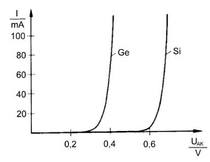

(2)
- For the circuit shown in the figure
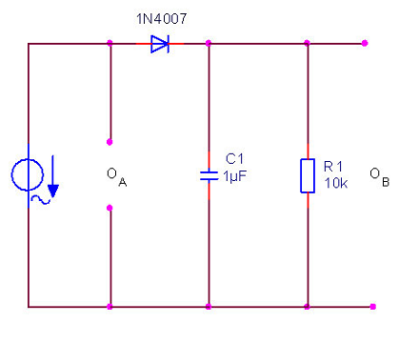
- What is the function of this circuit?
Ans. / clipping for the negative cycles of input signal and decrease ripples
- Trace the expected output at the oscilloscope (X-T) for 5V peak sinusoidal input signal.
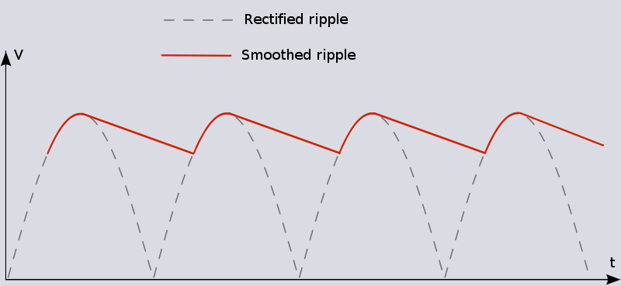
- Remove the capacitor and re-trace the output

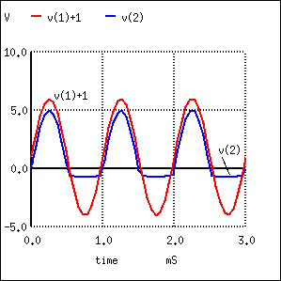
- What occurs by changing the resistor to 4.7K, and 100K?
Ans. / as resistor increase, the ripples decreases and the output smooth to dc.
- Which of the following statements are correct? The ripple...
- Becomes lower as the load increases.
- Always remains the same.
- Becomes lower as the load decreases.

